11500811G QING Pei
10670906G YIP Chung Chung
10606122G MO Lee Chun
11521100G SO Chun Fai

Critical Concepts

4Is
Intangible:
Personal attention received from the patient after installing the system, employee can have more time to pay more attentions on the patient.
Employee got lesser stress since some procedures are replaced by computer.
[the computerized reception system can provide a hi-tech impression to the customer in the first sight-> have hi-tech medical procedures(bill)]

Inventory:
Patients’ personal information and diagnosis are written in papers.
[patients' result of diagnosis is recorded for feather treatment or follow-up consultation(bill)]

Inconsistent:
patient’s diagnostic result.
same patients consulted by different doctors, may have different diagnostic result, and different manner.

[the input and selection is standardized in the reception system(bill)]

Inseparable:
Diagnostic program and the doctor followup
[the influence from others reduced as patient can use the system individually with some help from one staff(bill)]

3Ps
People:
[the stress of the staff decreased as some process can be done by the system, then they can devote more time and energy to provide empathy and responsiveness services(bill)]

Physical:
Reception equipment
[same as Intangible......(bill)]

Process:
The process since the patient come for registration, diagnostic and followup by the doctor.
[the service operation is standardized and simplified, the processing time may decreased and the service become more reliability and assurance(bill)]

Service Encounter
|Reception Greeting|-->|Registration|-->
[
1.seeing exterior signage->
2.reception(star)->
3.consultation(star)->
3b.treatment->in-patient->(may be skip)
4.pharmacy->
5.cashier

role of reception:
registration
estimate the illness of the patients by the first sight and performing some measurement
recommend the suitable department to the patients
(Bill)]

Service Quality

Provider Gaps
[gap1:don’t know what patients expected
gap2:can't design suitable service to fulfill patients' expectation
gap3:staff can't perform the service to fulfill patients' expectation
gap4:the patient fail to acknowledge the actual service you provided
(Bill)]

Redesign of the Service

Issues Regarding the ITIL Framework

Introduction(d)
- Background

Service Analysis
- 4I and 3P(d)
- Service Encounter(e)
- Service Quality, Perception, Exception RATER(e)
- Gaps Model analysis(b)

Service Redesign
- Critical provider gap(b)
- Improvement plan
- blue prints
- scheduling
- monitoring
- controlling
*- ITIL framework, implementation plan (r)
Conclusion
Appendix

Introduction
This paper is discussed about the current services of Health care center in terms of services science management concepts. From this paper, we’ll analysis the services provided by Health care center in several dimension. First, we present the characteristics of the services by 4Is and 3Ps, thus identify the process of the services with Service encounter model. Base on the service encounter, analysis the service quality with RATER and hence, to identify the provider gaps. Then, redesign the service base on IT improvement in terms of six sigma project.

Background
Health care center is large health center that contain 3,000 employee and 200,000 members, providing health consultation services for any kind of patients, it provides health consultation, medical treatment and pharmacy. More, it’s now struggling about installation of the new reception system will computerizing the current existing service procedure.

4Is
Intangible:
Employee manner

Inventory:
Patients’ personal information and diagnosis are written in papers.
patients' result of diagnosis is recorded for feather treatment or follow-up consultation
medicine for cure patients.

Inconsistent:
patient’s diagnostic result.
Same patient consulted by different doctors, may have different diagnostic result, and different manner.

Inseparable:
Diagnostic result and the doctor followup
Doctor manner affect the patient’s feeling

3Ps
People:
Receptionist helps patient to register the services, retrieve the patient diagnostic records, printing insurance receipt.
Doctor consult the patients
nurse allocate the medicine to the patients

Physical:
Diagnostic equipment
Reception waiting area

Process:
Reception registration process when the patients walk in
Health consultation process for each patient.

Service Encounter
Top level:
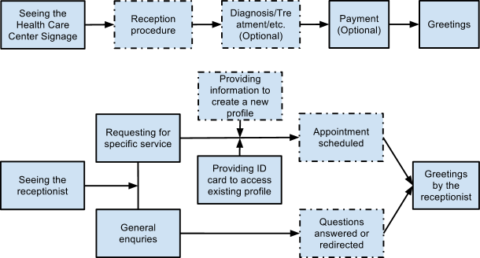
Service Quality Dimensions (RATER)
Reliability:
- Are the receptionists following the standardized procedure?
- Is the estimated waiting time accurate?
Assurance :
- Is private information of patients well protected from unauthorized access?
- Do patients trust the receptionists in their capabilities?
Tangibles:
- Receptionist in uniform is the image of the service.
- The equipments and technology used at the reception area reflects the physical competence of health care center.
Empathy:
- Are the staff/information accessible to every patient’s request?
- Do receptionists communicate with the patients in a clear, appropriate way?
- Can the staff understand the patients’ situations well?
- Are receptionists capable of full-filling individualized needs of patients?
Responsiveness:
- Can receptionists respond to patients’ requests/questions promptly?
- Are receptionists always willing to help all patients?
- Are receptionists capable of handling emergencies?

Gaps Model analysis(b)
Gap1:
1. management think the patient only concern about the quality of the cure and ignore the reception part
2. do survey on the quality of cure only, ignore other services provided
3. the participants of the survey is their patient, no idea of the expectation from the one who didn’t choose QC
Gap2:
1. the hand-writing record is too low-tech to provide a efficiency performance
2. the huge amount of the physical record decrease the searching efficiency
3. the low-tech reception system is not able to provide confident
4. hard to collect and analyze the data for statistics and estimation
Gap3:
1. the staff don’t pay attention during registration and make mistake.
2. The staff don’t have skill to perform efficiency searching from the huge physical record
3. The staff may be stressed by the complex operation of the registration
4. The staff may be confused by the hand-writing record
5. The staff is so tired to provide empathy service
Gap4:
1. patient expect QC don’t have hi-tech treatment after the first sight of the low-tech reception system
2. patient is scared by the long queue of reception and expect that QC has a messy organization and operation system

Critical provider gap(b)
After redesigned of the dimension and sampling method of the survey, it was found that the reception part is the critical part which dissatisfying the patient, after that we estimate that there would not be a great improvement if we just focus on skill training or strict staff instruction to improve the performance of staff on the old-design system. Hence we will focus on gap2 to improve the service quality; we will redesign and computerize the reception system to improve the performance of reception.

V...sorry for the chaotic english writing(Bill)
Gaps Model analysis
As stated before, the bottleneck is occurred at the “Patients’ information registration”, the bottleneck is mainly caused by several weakness on “people” and “process”, which can be classified into three gap: “Knowledge Gap”, “Designs and Standards Gap” and “Performance Gap”.
Knowledge Gap is the weakness on the searching, understanding and analysis on the customer expectation. The management of QC put all their concentration on their customer, they do the survey based on the patients who stay at the waiting area, they have miss the one who is dissatisfied and leaved in reception area, hence they can just got the feedback as “the cure quality is good” or “the waiting time to see a doctor is too long”, and neglected the critical weakness in reception area. John Sitzia and Neil Wood (1997)[1] had concluded a Fitzpatrick framework in there research which stated that the receptionist is one of the factor affecting the accessibility of a hospital, customer may leave if they are hard to access to the doctor. Due to the miss of the opinions from the dissatisfied customer, the management of QC may have wrong decision in the reception service design which causes the critical weakness from the registration part.
Designs and Standards Gap is the weakness on the design of the system and standard to provided satisfactory service which the management will to provide after the analysis of customer expectation. Although the service of the reception is underestimated as the fail on the Knowledge Gap, the current registration system is too inefficiency to fulfill the daily operation of the hospital. The system only allow the staff to record the information in hand writing, in the survey from Jill Gladstone(1995)[2], most of the medical errors were caused by the illegible hand writing, and there are 12.7% of error is caused by “incorrect patient”, nurses or doctors may have made mistake on the patient’s information from the handwriting registration record, this may also cause the redundancy of registration if the nurse fail to search for the existing patient’s record with the bad handwriting; the huge amount of the physical record is not able to provide a efficiency searching environment, nurses need to search the record from drawers after asking the basic information to check whether he or she is a registered patient, then there will be a waiting time before registration, which longer the time of registration process; the registered patient is served with the unregistered in a same line, the query may get stuck to wait for the registration.
Performance Gap is the weakness of the staffs or customer to use the designed system to provide or enjoy satisfactory service, which is mainly base on the ability and characteristic individually; there may be error input caused by spelling mistake and time spent on the correction; the staff is too slow in recording and searching so that the query stuck at the peak time; the staff may be confused by the hand-writing record in file searching; the staff do not pay enough attention on registration; the staff may be stressed by the complex operation of the registration; the patient may be stressed by the illness; the patient is not able to present their personal information and the staff is not helpful enough to help them; and there are still many of unexpected matter occur as the ability and characteristic is not identical.
Critical provider gap
The Designs and Standards Gap is decided to be the critical provider gap, the analysis is stated below:
To improve the Knowledge Gap, the sampling base should have to be redesign to cover the entire target market, and the survey should have to be redesign to cover the entire services provided. However improving this gap can just help to identify the customer expectation and the problem of service for feather improvement, which is not critical to deal with.
To improve the Performance Gap, some training can be provided to improve the skill of shorthand, filing and searching document, stress and emotion handling for the staff; hire additional staff to do the searching or open more line for registration. However, the limitation of the system cause bottleneck in the registration: for example it is hard for more than one person searching the file in the same drawer, the improvement may not be significant.
For the Designs and Standards Gap, there is a obviously critical problem that the handwriting system and the disordered operation process has limited the efficiency of performance, hence the system and process have to be redesign.

IT Improvement project (SIX Sigma)
The Improvement project which covered by by ITIL framework

As we have to make an IT improvement project to our service, We should to make use of ITIL framework : Service Level Management, Availability Management in Service Design Processes and Access Management, Incident Management in Service Operation Processes to keep our service quality to satifactory our customer.

Service Level Management --- Since the new “Receptionist System” will implementation with external Vendor, so that we have to manage our expectation and vendor’s perception to reduce the service between us. And we use Service Level Management to define the scope, document it and let both’s management team agree the term and sign-off. To ensure that specific and measurable targets are developed for vendor provided IT services.
It can Manages the expectation and perception of the business, customers and users and ensures that the quality of service delivered by the IT service matches those expectations and needs. After the system development were done and deploy into hospital successful, SLM can help us to establishes and maintains SLAs for current live services and manages the level service provided to meet the targets and quality measurements contained within the SLAs. Moreover, for support on-going business change, SLM produces and agrees to Service Level Requirements (SLRs) for all planned new or changed services.
To keep our service level were on target, we can make use of Key Performance Indicators (KPIs) and metrics can be used to judge the efficiency and effectiveness of the SLM activities and the progress of a Service Improvement Program(SIP).

(the over view of Service Level Management.)
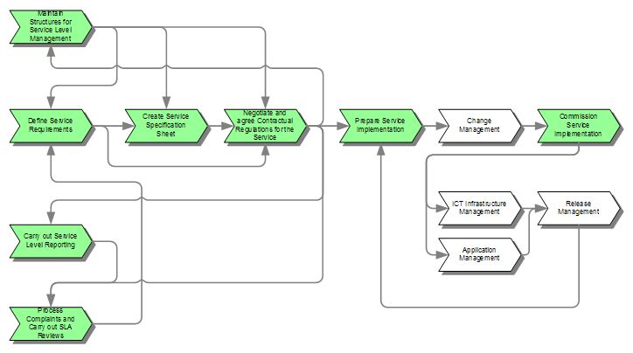

Availability Management --- Since our hospital switch one of our criticial service encounter into system, so we have to make use of Availability Management process to ensure that the level of service availability delivered in all services is matched to or exceeds the current and future agreed needs of the business, in a cost-effective manner.
As the important of this IT service, Availability Management produces and maintains an appropriate and up-to date Availability Plan, which reflects the current and future needs of the business. And ensures that service availability achievements meet or exceed all of their agreed targets by managing the services and resources that are related to availability performance. Such like Backup Plan for DB Server, Network Connection failover plan, Hot stand-by technical.

(the over view of Availability Management.)
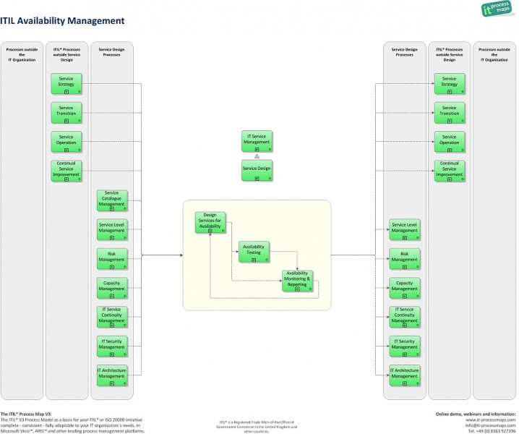

Access Management --- Since our system were holding our most personal confidential information, so that we have to better control / manage the right person in right process to access right patient’s information. Access Management grant authorized users the right to use a service while preventing access to unauthorized users and making sure that the policies and actions defined in Security and Availability Management are executed appropriately by three difference area:

Access --- The level and extent of a service’s functionality or data that a user is entitled to use.

Identity --- Information about the users that distinguishes them as individuals and verifies their status within the organization. By definition, the identity of a user is unique to that user.

Rights --- Also called privileges, right refer to the actual settings where a user is provided access to a service or group of services. Typical rights, or levels of access, include read, write, execute, change, and delete.

Services or Service Groups --- Users performing a similar set of activities will use a similar set of services. Instead of providing access to each service for each user separately, it is more efficient to be able to grant each user or group of users access to the entire set of services that the user is entitled to use at the same time.

Directory Services --- Refers to a specific type of tool that is used to manage access and rights.

(the over view of Access Management.)
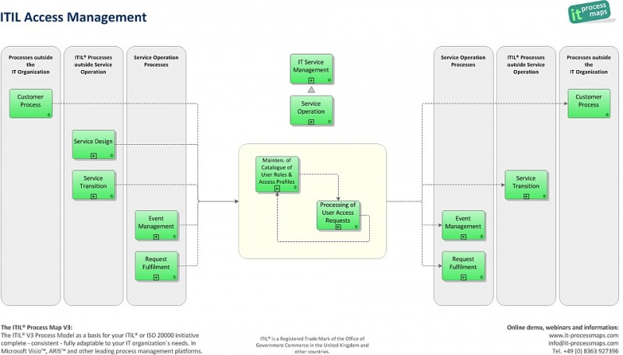
Incident Management --- Since the IT service were very important, and we have to make use of Incident Management to handle the unexpected incident to restore normal service operations as quickly as possible and minimize the adverse impact on business operations. Which ensure that the best possible levels of service quality and availability are maintained as we already defined within agreed Service Level Agreement (SLA) limits.

Moreover, the incident management sub-process incident Closure and Evaluation now states more clearly that it is important to check whether there are new Problems, Workarounds or Known Errors that must be submitted to Problem Management.

(the over view of Incident Management.)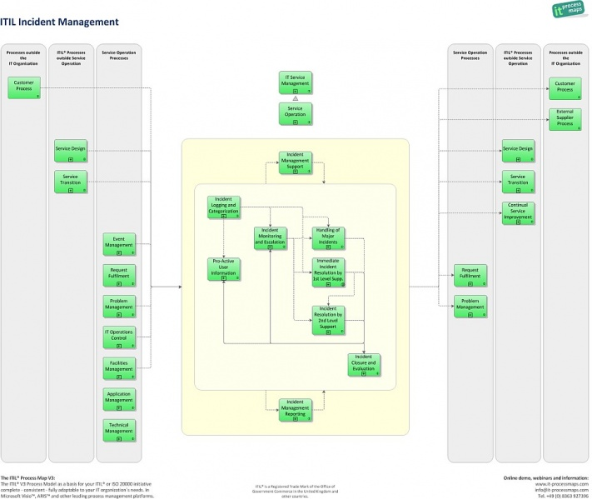

Reference.

[1] Sitzia J, Wood N.(1997) Patient satisfaction: a review of issues and concepts. Worthing Nursing Development Unit, Worthing Hospital, U.K.
[2] Gladstone J.(1995) Drug administration errors: a study into the factors underlying the occurrence and reporting of drug errors in a district general hospital. Royal Devon and Exeter Hospital, England.

[3] IT Process Maps - A fresh Approach to implementing ITIL
http://en.it-processmaps.com/

